Hypertension (High Blood Pressure)

Blood pressure is a measurement of the force against the walls of your arteries as your heart pumps blood through your body. Hypertension is another term used to describe high blood pressure.

Blood pressure readings are usually given as two numbers -- for example, 120 over 80 (written as 120/80 mmHg). One or both of these numbers can be too high.

The top number is called the systolic blood pressure. The bottom number is called the diastolic blood pressure.

* Normal blood pressure is when your blood pressure is lower than 120/80 mmHg most of the time.
* High blood pressure (hypertension) is when your blood pressure is 140/90 mmHg or above most of the time.
* If your blood pressure numbers are 120/80 or higher, but below 140/90, it is called pre-hypertension.

If you have heart or kidney problems, or you had a stroke, your doctor may want your blood pressure to be even lower than that of people who do not have these conditions.

**Causes, incidence, and risk factors**

Many factors can affect blood pressure, including:

* How much water and salt you have in your body
* The condition of your kidneys, nervous system, or blood vessels
* Your hormone levels

You are more likely to be told your blood pressure is too high as you get older. This is because your blood vessels become stiffer as you age. When that happens, your blood pressure goes up. [High blood pressure](http://www.ncbi.nlm.nih.gov/pubmedhealth/PMH0001502/)increases your chance of having a stroke, heart attack, heart failure, kidney disease, or early death.

You have a higher risk of high blood pressure if:

* You are African American
* You are obese
* You are often stressed or anxious
* You drink too much alcohol (more than one drink per day for women and more than two drinks per day for men)
* You eat too much [salt in your diet](http://www.ncbi.nlm.nih.gov/pubmedhealth/n/pmh_adam/A002415/)
* You have a family history of high blood pressure
* You have diabetes
* You smoke

Most of the time, no cause of high blood pressure is found. This is called essential hypertension.

High blood pressure that is caused by another medical condition or medication is called secondary hypertension. Secondary hypertension may be due to:

* [Chronic kidney disease](http://www.ncbi.nlm.nih.gov/pubmedhealth/n/pmh_adam/A000471/)
* Disorders of the adrenal gland (such as [pheochromocytoma](http://www.ncbi.nlm.nih.gov/pubmedhealth/n/pmh_adam/A000340/) or [Cushing syndrome](http://www.ncbi.nlm.nih.gov/pubmedhealth/n/pmh_adam/A000410/))
* [Hyperparathyroidism](http://www.ncbi.nlm.nih.gov/pubmedhealth/n/pmh_adam/A001215/)
* Pregnancy or [preeclampsia](http://www.ncbi.nlm.nih.gov/pubmedhealth/n/pmh_adam/A000898/)
* Medications such as birth control pills, diet pills, some cold medicines, and migraine medicines
* Narrowed artery that supplies blood to the kidney ([renal artery stenosis](http://www.ncbi.nlm.nih.gov/pubmedhealth/n/pmh_adam/A000204/))

**Prevention**

The same lifestyle changes you may follow to help control your blood pressure will also help prevent high blood pressure from occurring in most people.

Diabetes

Diabetes is usually a lifelong (chronic) disease in which there is a high level of sugar in the blood.

**Causes, incidence, and risk factors**

[Insulin](http://www.ncbi.nlm.nih.gov/pubmedhealth/PMHT0010723) is a hormone produced by the pancreas to control blood sugar. Diabetes can be caused by too little insulin, resistance to insulin, or both.

To understand diabetes, it is important to first understand the normal process by which food is broken down and used by the body for energy. Several things happen when food is digested:

* A sugar called glucose enters the bloodstream. Glucose is a source of fuel for the body.
* An organ called the pancreas makes [insulin](http://www.ncbi.nlm.nih.gov/pubmedhealth/PMHT0010723). The role of insulin is to move glucose from the bloodstream into muscle, fat, and liver cells, where it can be used as fuel.

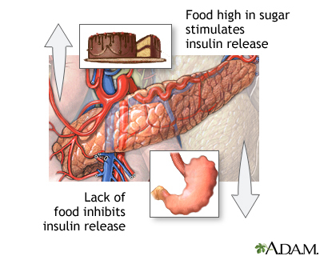

People with diabetes have high blood sugar because their body cannot move sugar into fat, liver, and muscle cells to be stored for energy. This is because either:

* Their pancreas does not make enough [insulin](http://www.ncbi.nlm.nih.gov/pubmedhealth/PMHT0010723)
* Their cells do not respond to [insulin](http://www.ncbi.nlm.nih.gov/pubmedhealth/PMHT0010723) normally
* Both of the above

There are two major types of diabetes. The causes and risk factors are different for each type:

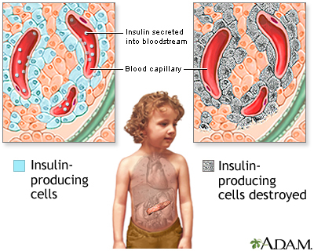

* [Type 1 diabetes](http://www.ncbi.nlm.nih.gov/pubmedhealth/n/pmh_adam/A000305/) can occur at any age, but it is most often diagnosed in children, teens, or young adults. In this disease, the body makes little or no [insulin](http://www.ncbi.nlm.nih.gov/pubmedhealth/PMHT0010723). Daily injections of insulin are needed. The exact cause is unknown.
* [Type 2 diabetes](http://www.ncbi.nlm.nih.gov/pubmedhealth/n/pmh_adam/A000313/) makes up most diabetes cases. It most often occurs in adulthood. But because of high obesity rates, teens and young adults are now being diagnosed with it. Many people with type 2 diabetes do not know they have it.
* There are other causes of diabetes, and some patients cannot be classified as type 1 or type 2.

[Gestational diabetes](http://www.ncbi.nlm.nih.gov/pubmedhealth/n/pmh_adam/A000896/) is high blood sugar that develops at any time during pregnancy in a woman who does not have diabetes.

Diabetes affects more than 20 million Americans. Over 40 million Americans have pre-diabetes (which often develops before type 2 diabetes). If your parent, brother or sister has diabetes, you may be more likely to develop diabetes.

**Symptoms**

High blood sugar level can cause several symptoms, including:

* Blurry vision
* Excess thirst
* [Fatigue](http://www.ncbi.nlm.nih.gov/pubmedhealth/n/pmh_adam/A003088/)
* Hunger
* Urinating often
* Weight loss

Because type 2 diabetes develops slowly, some people with high blood sugar have no symptoms.

Symptoms of type 1 diabetes develop over a short period. People may be very sick by the time they are diagnosed.

After many years, diabetes can lead to other serious problems. These problems are known as diabetes complications and include:

* [Eye problems](http://www.ncbi.nlm.nih.gov/pubmedhealth/n/pmh_adam/A001212/), including trouble seeing (especially at night), light sensitivity, blindness in the future
* Painful sores and infections of the leg or foot, which if left untreated, leads to removal of the foot or leg
* [Nerves in the body can become damaged](http://www.ncbi.nlm.nih.gov/pubmedhealth/n/pmh_adam/A000693/), causing pain, tingling, and a loss of feeling, problems digesting food, erectile dysfunction
* [Kidney problems](http://www.ncbi.nlm.nih.gov/pubmedhealth/n/pmh_adam/A000494/), which can lead to [kidney failure](http://www.ncbi.nlm.nih.gov/pubmedhealth/n/pmh_adam/A000471/)
* Weakened immune system, which can lead to more frequent infections
* Increased chance of having a [heart attack](http://www.ncbi.nlm.nih.gov/pubmedhealth/n/pmh_adam/A000195/) or [stroke](http://www.ncbi.nlm.nih.gov/pubmedhealth/n/pmh_adam/A000726/)

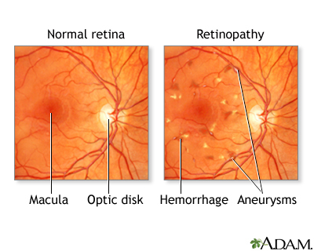

**Prevention**

Keeping an ideal body weight and an active lifestyle may prevent type 2 diabetes.

Type 1 diabetes cannot be prevented.

Cancer (**Carcinoma; Malignant tumor)**

Cancer is the uncontrolled growth of abnormal cells in the body. Cancerous cells are also called malignant cells.

**Causes, incidence, and risk factors**

Cancer grows out of normal cells in the body. Normal cells multiply when the body needs them, and die when the body doesn't need them. Cancer appears to occur when the growth of cells in the body is out of control and cells divide too quickly. It can also occur when cells forget how to die.

There are many different kinds of cancer. Cancer can develop in almost any organ or tissue, such as the lung, colon, breast, skin, bones, or nerve tissue.

There are many causes of cancer, including:

* Benzene and other chemicals
* Drinking excess alcohol
* Environmental toxins, such as certain poisonous mushrooms and a type of poison that can grow on peanut plants (aflatoxins)
* Excessive sunlight exposure
* Genetic problems
* Obesity
* Radiation
* Viruses

However, the cause of many cancers remains unknown.

The most common cause of cancer-related death is lung cancer.

The three most common cancers in men in the United States are:

* [Prostate cancer](http://www.ncbi.nlm.nih.gov/pubmedhealth/n/pmh_adam/A000380/)
* [Lung cancer](http://www.ncbi.nlm.nih.gov/pubmedhealth/n/pmh_adam/A000122/)
* [Colon cancer](http://www.ncbi.nlm.nih.gov/pubmedhealth/n/pmh_adam/A000262/)

In women in the United States, the three most common cancers are:

* [Breast cancer](http://www.ncbi.nlm.nih.gov/pubmedhealth/n/pmh_adam/A000913/)
* Colon cancer
* Lung cancer